The gross pneumatic packer BVP with residue-free
emptying on change of product as a crowd-puller
The Möllers Group presented new solutions for the efficient and clean filling of bulk solids at Powtech
Beckum, April 2016. "Powtech has far exceeded our expectations in terms of quality and quantity of contacts!" Ralf Drews, CEO of Greif-VELOX, was able to draw this successful conclusion following Powtech. At the International Trade Fair for Mechanical Process Engineering and Analysis in Nuremberg, the Möllers Group played a special trump card with solutions from its subsidiary, the company GREIF-VELOX from Lübeck - and perfected the compact and clean filling of bulk solids.
"For the Möllers Group, the Powtech presence has been a complete success," reported Dr. Gerd Reil, Sales Maschinenfabrik Möllers GmbH. Decision makers from all over the world and from many industries, but especially the chemical and food industry, familiarized themselves with the high-performance machines for filling, palletizing and wrapping, the wide range of applications and industries. The trade fair concept proved its worth: trade fair visitors were impressed by the functionality and technologies of the current machines.
The gross pneumatic packer BVP proved to be a crowd puller with residue-free emptying when changing products thanks to its innovative boiler shape, additional blowing nozzles and optimized control of the product conveying air.
He was assisted by the new automatic applicator for single-spout systems. With a small footprint, the VALVOMAT S1 convinces with a low error rate and achieves top marks ​​of 99.7% for the application rate, the guests learned first-hand from Bernd Tillack, Head of Process Engineering GREIF-VELOX.
The vaporizer VELOVAC was presented particularly vividly. His unique assets visualized an air column in which paper balls floated. With it, GREIF-VELOX opens up new dimensions in the dust-free filling of extremely light bulk materials in a vacuum process with up to four-fold product compaction.

Just in time for the fair, the latest bottling results with carbon black were presented. The super-compact bags of only 9cm in height without additional pressing and the 1A pallet pattern were a pilgrimage goal for the customer and also impressed the trade fair audience.
The patented, fully-automatic VALVOCUT valve cutter, which made the perfect cut to prevent valve overhangs after welding, was always surrounded.
"The Valvocut prevents product residues in the valve area from contaminating pallet loads - a real selling point for many customers," commented Henrik Johns and Jörg Scharwies from the sales department.
Companies in the packaging industry demand a partner who guarantees flexible, efficient working with state-of-the-art technology. A task which is fulfilled by the Möllers Group with a high degree of automation in production, adapted constructions and tailor-made solutions even for extremely difficult bulk materials.
Since 1952, the Möllers Group has been building on the Full Line. High Quality. Möllers convinces in the palletizing sector with exact, extremely gentle results for products of many industries. As a strong alliance, the Maschinenfabrik Möllers as a professional for palletizing and packaging and GREIF-VELOX as a competent partner for bottling expertise under the umbrella of the Möllers Group, reflect this idea of ​​the Full Line.

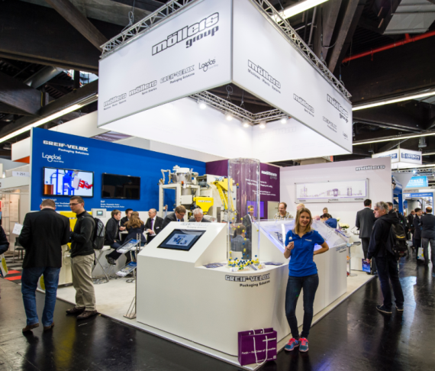

If the handling of light goods becomes "child's play": The presentation of the Velovac was charmingly supported by a fair hostess who distributed air whistles to the visitors.

